Practical No.9
Develop application to download image/video from server or upload image/video to server using MTOM techniques
MTOM (Message Transmission Optimization Mechanism)
Step1: Create a Project with Name CCWS_MTOM_Server
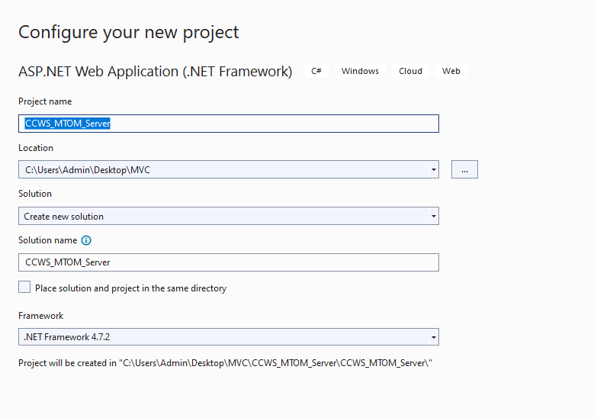
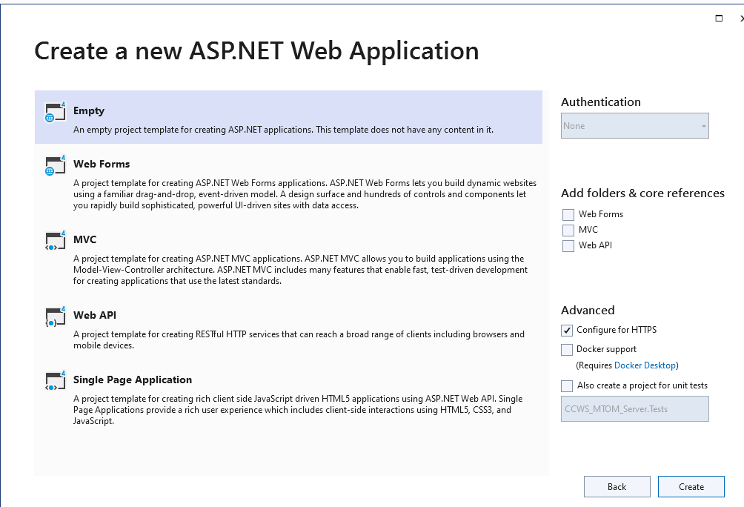
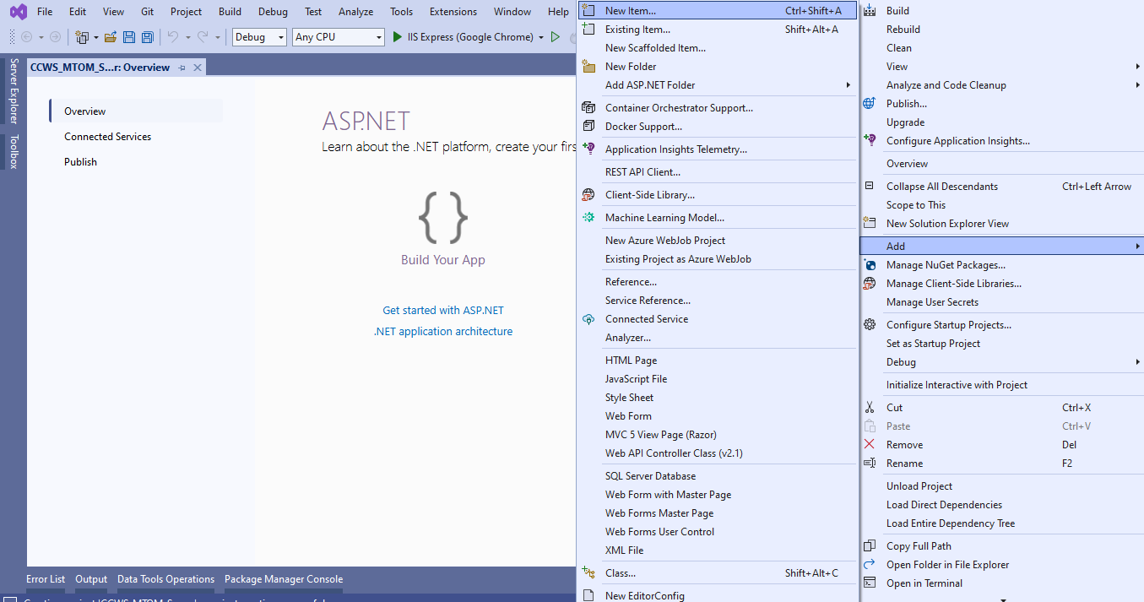
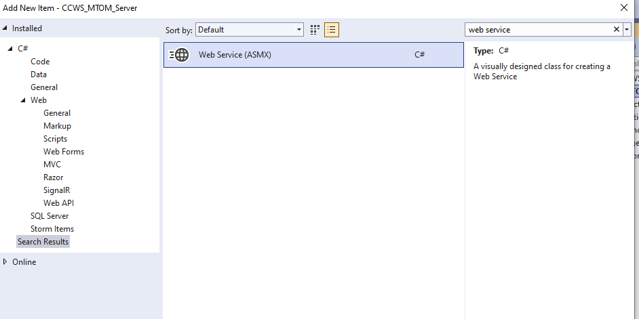

Change name to DownloadImageWS.asmx
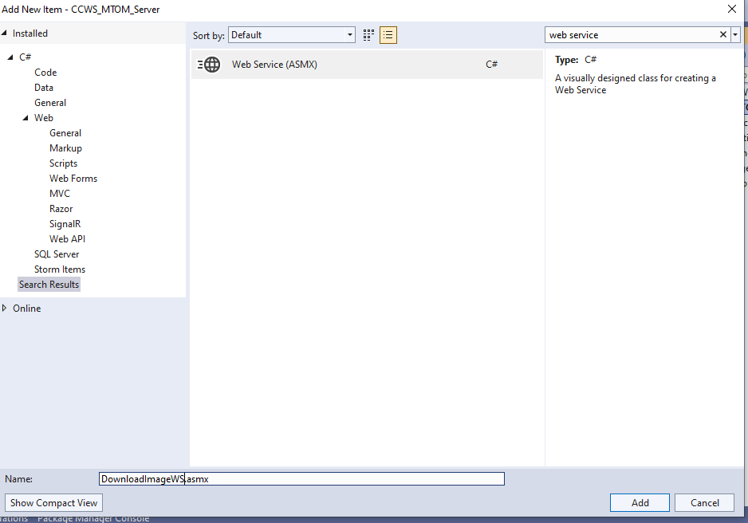
using System;
using System.Collections.Generic;
using System.ComponentModel;
using System.Linq;
using System.Web;
using System.Web.Services;
namespace MTOM_AMIN_6010_TYCS
{
/// <summary>
/// Summary description for WebServiceAmin
/// </summary>
[WebService(Namespace = "http://tempuri.org/")]
[WebServiceBinding(ConformsTo = WsiProfiles.BasicProfile1_1)]
[System.ComponentModel.ToolboxItem(false)]
// To allow this Web Service to be called from script, using ASP.NET AJAX, uncomment the following line.
// [System.Web.Script.Services.ScriptService]
public class WebServiceAmin : System.Web.Services.WebService
{
[WebMethod]
public string HelloWorld()
{
return "";
}
[WebMethod, Description("Get Image")]
public byte[] GetImageFile(String filename)
{
if (System.IO.File.Exists(Server.MapPath("~/Images/") + filename))
{
return System.IO.File.ReadAllBytes(Server.MapPath("~/Images/") + filename);
}
else
{
return new byte[] { 0 };
}
}
}
}
Step2 : Create a handler file for MTOM.
Goto Solution Explorer -> Right Click and Add GenericHandler
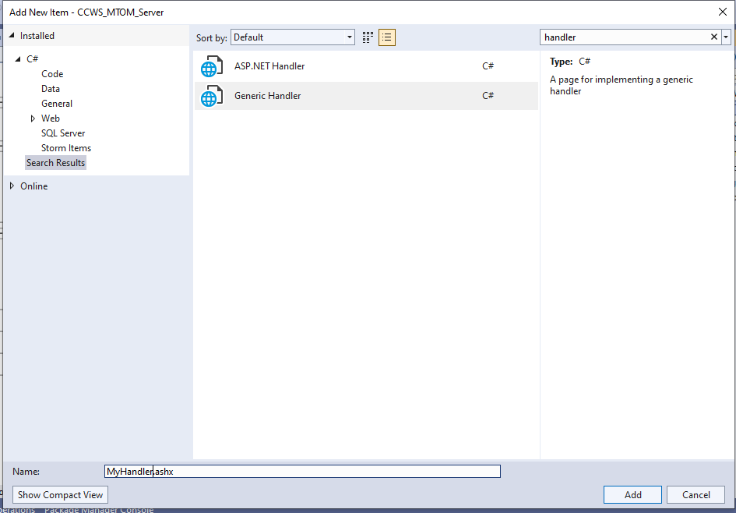
using System;
using System.Collections.Generic;
using System.Linq;
using System.Web;
using System.Web.UI;
namespace MTOM_AMIN_6010_TYCS
{
/// <summary>
/// Summary description for HandlerAmin
/// </summary>
public class HandlerAmin : IHttpHandler
{
public void ProcessRequest(HttpContext context)
{
WebServiceAmin ws = new WebServiceAmin();
byte[] binImage = ws.GetImageFile(context.Request["filename"]);
if (binImage.Length == 1)
{
}
else
{
context.Response.ContentType = "image/jpeg";
context.Response.BinaryWrite(binImage);
}
}
public bool IsReusable
{
get
{
return false;
} } } }
Step3 : Create a Webform1.aspx as follows
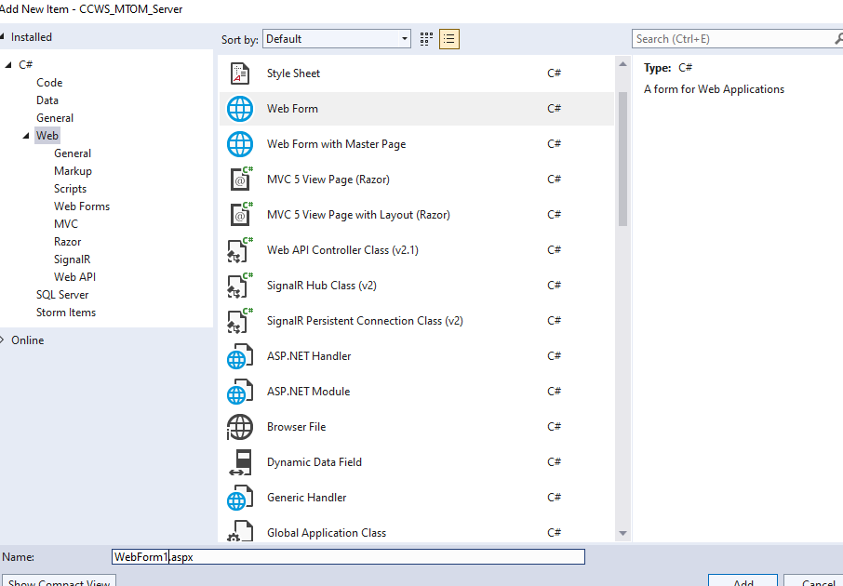
WebformAmin.aspx
<%@ Page Language="C#" AutoEventWireup="true" CodeBehind="WebFormAmin.aspx.cs"
Inherits="MTOM_AMIN_6010_TYCS.WebFormAmin" %>
<!DOCTYPE html>
<html xmlns="http://www.w3.org/1999/xhtml">
<head runat="server">
<title></title>
<h1> SUFYAN ANSARI 6111</h1>
</head>
<body>
<form runat="server">
<center>
<asp:Label ID="Lbl1" runat="server" Text="Enter Image Name"></asp:Label>
</center>
<center>
<asp:TextBox ID="Txt1" runat="server" OnTextChanged="Txt1_TextChanged"></asp:TextBox>
</center>
<center>
<asp:Button ID="Btn1" runat="server" Text="Download Image"
OnClick="Btn1_Click" Height="20px" Width="300px" />
</center>
<center>
<asp:Image ID="Image1" runat="server" Height="350px" Width="350px" />
</center>
</>
</form>
</body>
</html>
Webform1.aspx.cs
using System;
using System.Collections.Generic;
using System.Linq;
using System.Web;
using System.Web.UI;
using System.Web.UI.WebControls;
namespace MTOM_AMIN_6010_TYCS
{
public partial class WebFormAmin : System.Web.UI.Page
{
protected void Page_Load(object sender, EventArgs e)
{
}
protected void Btn1_Click(object sender, EventArgs e)
{
{
Image1.ImageUrl = "~/HandlerAmin.ashx?filename=" + Txt1.Text;
Response.Write("Downloading Of Image Is Done");
}
}
protected void Txt1_TextChanged(object sender, EventArgs e)
{
}
}
}
Create a folder with name images and copy and paste the image as follows.
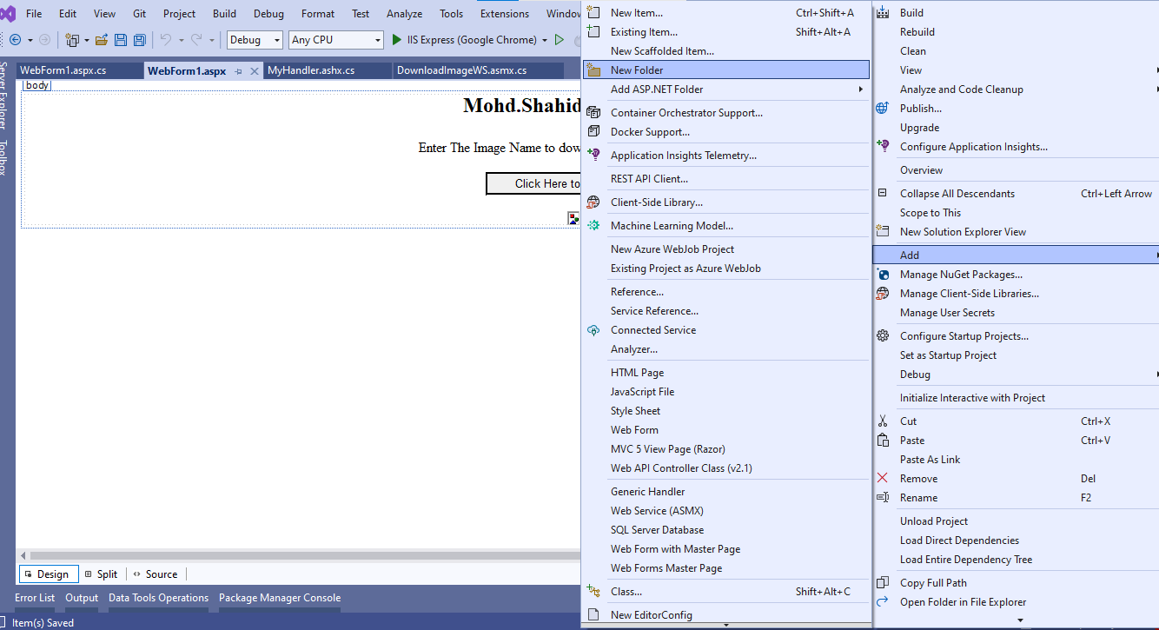
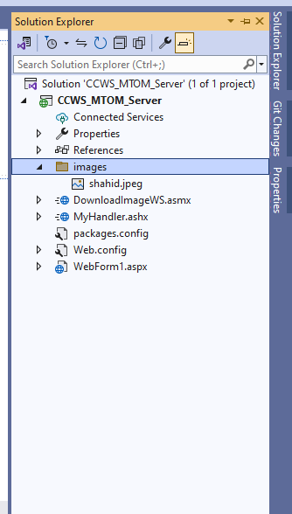
OUTPUT:-

